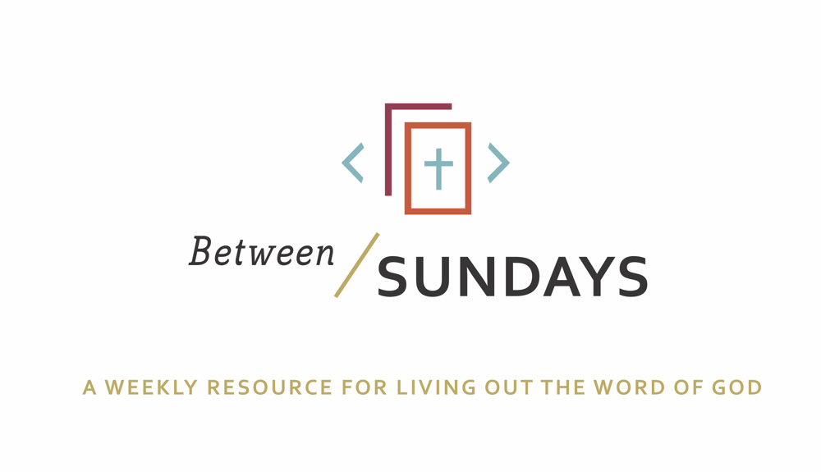
What: a weekly resource that helps the community of CCE take the sermon into their lives throughout the week with a variety of reflections, group discussions, and individual practices.
Why: Sermons aren't just for Sunday morning. “We submit ourselves to the way of faith and practice revealed in the Word of God. The sermon is explanation and exhortation, making this Word clear and applying it to our lives.” (definition on bulletin)
Individual and communal rhythms that help us take the liturgy into daily life allow us to open ourselves to what God is teaching us through his Word and his people.

Feel free to go through all the days, or select one or two exercises that help you apply the sermon to your life this week.

December 1, 2019
Sermon Title: For Joy
Dan DeCriscio

Passage: John 11:17-36
Key idea: We do not wait in vain because Jesus give us His Light, His Life, and His Power.

Monday: Lectio Divina
Take some time to practice an ancient way of reading Scripture. For more on lectio divina, see the additional resources at the end.

-(Lectio) Reading. Slowly read the sermon text (John 11:27-36) ) and get a sense of what it is saying. Read it a second time and listen for any words that strike you.
- (Meditatio) Reflecting. Read the passage again slowly. As you pause on the words or phrases that stick out to you, take some time to consider what the word, passage, or phrase means (in the context of Scripture) and how God might be using it to speak to anything in particular in your life.
- (Oratio) Responding. Read the passage again, slowly. Consider now how God has spoken to *you* in this passage and respond back to him.
- (Contemplio) Remaining. Now, take time to simply remain in the presence of God.

Tuesday: Discussion Guide
Each week we’ll provide some questions to consider that will help you take the Scripture and the sermon into a deeper place. We hope this fosters meaningful conversations with those in your community group, your spouse or a friend. Authentic change happens in community.

- How does the Gospel put our waiting in a new perspective?
- Can you understand why the world would reject Jesus? Why does the world - who waits without hope, hate the Gospel? How would you give an account to the hope that is in you, to an unbeliever?
- When we’re in the “waiting fog” as Dan called it, we ask questions, feel confused or abandoned and generally don’t want to be waiting. Those around us can serve as lights on our journey- lights in the darkness pointing us to Jesus and reminding us of hope. Who has been a light in your darkness during the waiting seasons of your life?
- Jesus "went away" to do his redeeming work and to enable us to receive power from on high - the Holy Spirit. Read Ephesians 4:30, Thessalonians 5:16-24, Hebrews 10:28 and 2 Timothy 1:6-10. What is Paul encouraging and discouraging in regards to the Holy Spirit? Describe your waiting in the context of what we are tempted to do and what the Spirit gives us power to do.
- Review the exchange between Martha and Jesus in the sermon text (v21-27) Note her questions and longing, and ultimately her profession of faith. Discuss this progression of her own faith with your group.
- Take a moment to reflect on the things you are currently waiting on. Write them down. Share them with God and no one else. How might God be inviting you to wait? In what ways is he forming you in this waiting season?

Wednesday: A prayer for Advent

God uses the Word (the Bible) and the word (sermons, conversations with friends, etc) to challenge and expose our hearts (Heb 4:12) consider how He is doing that in your life currently as you bring your confession to him.

Come thou long expected Jesus, born to set thy people free. On this first Sunday of Advent we acknowledge that we are waiting for you. We long for you to set us free from our sins and failures. To bring an end to our sorrows and pain. To heal our broken hearts and restore our relationships.
Come, Lord Jesus.
We wouldn’t willingly choose this waiting season; we’ve become accustomed to instant everything. We want quick resolution to our problems and we want our pain to be healed yesterday. Yet, it is in the waiting seasons of life that you shape our hearts to look like yours. Have mercy on us Lord, and allow us to open ourselves to be shaped by you, instead of our own way.
Come, Lord Jesus.
And yet, our waiting is not in vain! You’ve brought hope to our waiting. You came to be with us and entered our world a vulnerable and innocent baby. You showed us how to wait with patience, kindness, gentleness, and love. We praise you for the gift of your Spirit, and we desire to worship you with our lives. May they be reflections of your love to this world.
Our longings are just reminders that you created us for more than this world. We give these longings back to you, and choose this day to wait with the hope you offer.
Hear our prayers.
Come, Lord Jesus.

Spend some time talking with God. Perhaps this confessional prayer stirred some deeper places in your soul that need to receive His grace.
As you received communion this past Sunday, what burden did God free your heart from?
Where do you sense God drawing you further to himself, his community, the world?
Be encouraged that he has given us the Holy Spirit to serve as our helper, it’s not our own strength that we “strive to enter his rest” (heb 4:11)

Thursday: Hymn Devotional

Come Thou Long Expected Jesus listen here

Come, Thou long expected Jesus
Born to set Thy people free;
From our fears and sins release us,
Let us find our rest in Thee.
Israel's strength and consolation,
Hope of all the earth Thou art;
Dear desire of every nation,
Joy of every longing heart.

Take a moment to listen to the song and read this Advent devotional

Friday: Sabbath/Soul Rest
*Each week we’ll take time to practice a holy rest. Carve out time for yourself to receive the gift of rest this week.

Exercise for the day: Practice presence
Find one, simple act of delight to do today – read a poem, listen to a song, drink a cup of coffee, take a short walk – and do it slowly, practicing presence to the moment and gratitude.

Reflect: What good things do I pass over daily in my helter-skelter rush through life?

(From Ruthlessly Eliminate Hurry by John Mark Comer)

Additional Resources:
Music for your Advent: Over the Rhine has several Christmas albums you should check out!
Rain for Roots “Waiting Songs” is great for the whole family.
Podcast: We Wonder: Advent https://podcasts.apple.com/us/podcast/december-1-the-jesse-tree/id1484584757?i=1000458323736

