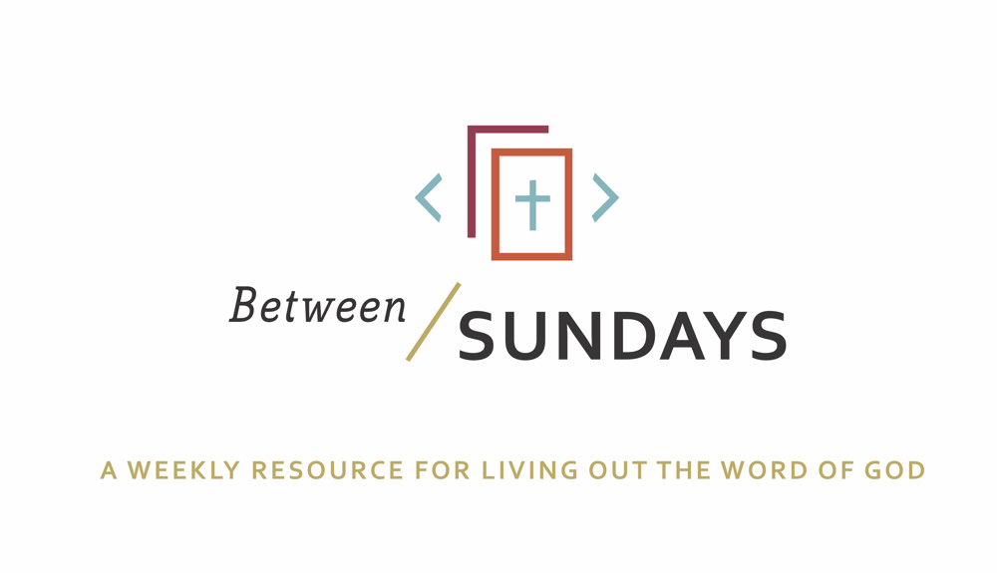
What: a weekly resource that helps the community of CCE take the sermon into their lives throughout the week with a variety of reflections, group discussions, and individual practices.
Why: Sermons aren't just for Sunday morning. “We submit ourselves to the way of faith and practice revealed in the Word of God. The sermon is explanation and exhortation, making this Word clear and applying it to our lives.” (definition on bulletin)
Individual and communal rhythms that help us take the liturgy into daily life allow us to open ourselves to what God is teaching us through his Word and his people.

Feel free to go through all the days, or select one or two exercises that help you apply the sermon to your life this week.

December 8, 2019
Sermon Title: Waiting for Hope
Scott Armstrong

Passage: Isaiah 11:1-10

Monday: Lectio Divina
Take some time to practice an ancient way of reading Scripture. For more on lectio divina, see the additional resources at the end.

-(Lectio) Reading. Slowly read the sermon text (Isaiah 11:1-10) and get a sense of what it is saying. Read it a second time and listen for any words that strike you.
- (Meditatio) Reflecting. Read the passage again slowly. As you pause on the words or phrases that stick out to you, take some time to consider what the word, passage, or phrase means (in the context of Scripture) and how God might be using it to speak to anything in particular in your life.
- (Oratio) Responding. Read the passage again, slowly. Consider now how God has spoken to *you* in this passage and respond back to him.
- (Contemplio) Remaining. Now, take time to simply remain in the presence of God.

Tuesday: Discussion Guide
Each week we’ll provide some questions to consider that will help you take the Scripture and the sermon into a deeper place. We hope this fosters meaningful conversations with those in your community group, your spouse or a friend. Authentic change happens in community.

1.Think back to your childhood—what were some of your greatest dreams and longings and why?

2. Can you think back to a time or event where your hopes and dreams felt particularly crushed? What did you decide was true of the world because of it? When have you felt cynical and why?

3. Scott said that often our hope “leaks out” in the form of addictions— or the unhealthy pursuit of our desires. We were made for more (than this world can offer) so we long for more. Think about your life presently, what areas might you be placing your God-given longings in the wrong things?

4.. Scott said that Jesus is the long-awaited Messiah who has come—our celebration of Christmas itself—filled with true wisdom, justice and power, and that He is the true “champion” we have waited for. How does that picture of Jesus for you impact your circumstances today and does it change anything going on in your life right now?

5. Look again at Isaiah 11:6-9, some of the most dramatic and life-giving poetry in all of the Old Testament. What do you feel when you envision this future to come? Do you believe that this day will come? If so, how does this “second Advent” change how you live today and work for hope in our society?

6. We’re living between the two Advents. The first, God brought his mercy in the form of Immanuel, God with us. The second advent will bring justice. It’s impossible to have a God of love without justice. Consider the complimentary qualities of God and discuss with your group. See Luke 4:18-19 for further reading.?

7.. Where is God asking you to take a step back and wait this Advent season? Are there areas of your life where He is inviting you to step away from striving and find instead a place of rest and transformation?

Wednesday: Confession
God uses the Word (the Bible) and the word (sermons, conversations with friends, etc) to challenge and expose our hearts (Heb 4:12) consider how He is doing that in your life currently as you bring your confession to him.
Confession:

Father, we confess that our hearts this morning are consumed either by cynicism—believing we should not expect more than the world can offer—or have been crushed in despair as we have watched our longings and hopes reduced to the ashes of failure. We acknowledge that our problem is not longing and hope itself but where we have placed our hopes. Forgive us for not waiting on You—not waiting with confidence today for your second Advent, Jesus. Jesus, encourage us, as we wait in this “in between time”, to trust that you will complete your new creation work both in our lives and in our cosmos. Amen.

Spend some time talking with God. Perhaps this confessional prayer stirred some deeper places in your soul that need to receive His grace.
As you received communion this past Sunday, what burden did God free your heart from?
Where do you sense God drawing you further to himself, his community, the world?
Be encouraged that he has given us the Holy Spirit to serve as our helper, it’s not our own strength that we “strive to enter his rest” (heb 4:11)

Thursday: Hymn Devotional

Anchor of Hope listen here

Great is the Lord, and most worthy of praise
Refuge of strength to the end
Righteous redeemer and mighty to save
He's the anchor of hope for the souls of men
Gracious, compassionate, merciful God
Radiant, holy delight
Beautiful Father, victorious son
Source of unchangeable light
Great is the Lord, and most worthy of praise
Refuge of strength to the end
Righteous redeemer and mighty to save
He's the anchor of hope for the souls of men

Spend some time listening to this song, and praise God that he is our true source of hope.

Friday: Sabbath/Soul Rest
*Each week we’ll take time to practice a holy rest. Carve out time for yourself to receive the gift of rest this week.

An invitation to rest in Gods presence: (adapted from Tara Owens, Anamcara ministries)

Spend a few minutes in silence, with your eyes closed.
Breathe deeply, fully, all the way down to your toes.
Receive God's sustaining breath in you and for you.
And open your hands (physically, yes).
Lay them palms up on your knees.
Hold them open and feel what God does.
Attend to what He is saying to you in the silence.
Attend to how He responds to your open hands.
And rest.
Rest in silence with Him.
It is enough.

Additional Resources:
Music for your Advent: https://open.spotify.com/playlist/7IZcWzt7r4XEdm2qIpUVzM?si=fzEPzmu1QV-wxVD9XGXFUg&nd=1

Book: Surprised By Hope by NT Wright
Podcast: The Next Right Thing episode 105

