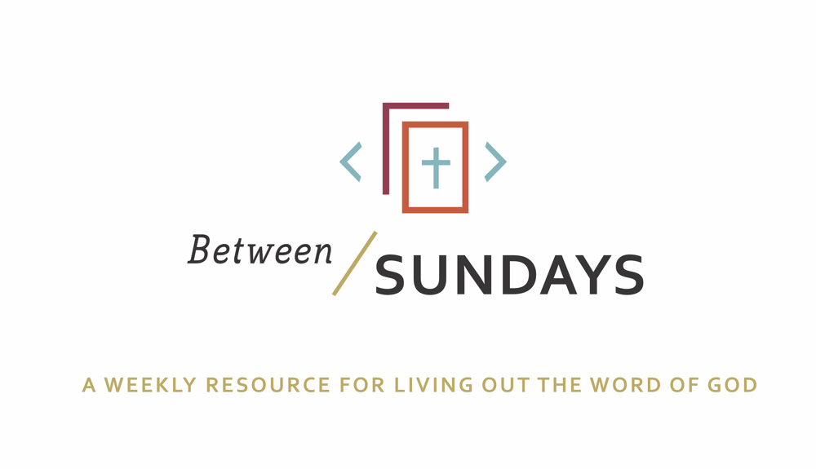
What: a weekly resource that helps the community of CCE take the sermon into their lives throughout the week with a variety of reflections, group discussions, and individual practices.
Why: Sermons aren't just for Sunday morning. “We submit ourselves to the way of faith and practice revealed in the Word of God. The sermon is explanation and exhortation, making this Word clear and applying it to our lives.” (definition on bulletin)
Individual and communal rhythms that help us take the liturgy into daily life allow us to open ourselves to what God is teaching us through his Word and his people.

Feel free to go through all the days, or select one or two exercises that help you apply the sermon to your life this week.

March 29, 2020
Mike Boland
Sermon Title: Shame
Sermon Series: Seeking Solace
Passage: Psalm 32:1-10

Quote: “If you put shame in a petri dish, it needs three ingredients to grow exponentially: secrecy, silence, and judgment. If you put the same amount of shame in the petri dish and douse it with empathy, it can’t survive.”
— Brené Brown

Summary: Emotional health is the care of the interior world for the flourishing of the outward life. This sermon focuses on the emotion of shame and how it impacts our relationship with God, and others. Psalm 32 explores David’s experience of shame, and how he offers a new way of living for his people that allows them to live in the freedom found from forgiveness. His humble reflection here also provides a lesson for the reader —the tension between keeping silent about our sin and confessing it to God and the spiritual community he’s placed us in.

Monday: Lectio Divina
Take some time to practice an ancient way of reading Scripture. For more on lectio divina, see the additional resources at the end.

-(Lectio) Reading. Slowly read the sermon text (Psalm 32:1-10) and get a sense of what it is saying. Read it a second time and listen for any words that strike you.
- (Meditatio) Reflecting. Read the passage again slowly. As you pause on the words or phrases that stick out to you, take some time to consider what the word, passage, or phrase means (in the context of Scripture) and how God might be using it to speak to anything in particular in your life.
- (Oratio) Responding. Read the passage again, slowly. Consider now how God has spoken to *you* in this passage and respond back to him.
- (Contemplio) Remaining. Now, take time to simply remain in the presence of God.

Tuesday: Discussion Guide
Each week we’ll provide some questions to consider that will help you take the Scripture and the sermon to a deeper place. We hope this fosters meaningful conversations with those in your community group, your spouse or a friend. Authentic change happens in community.

- Review from last week: Scott said that he experienced God’s guiding presence especially through the church family providing for them in their hour of need. This is referred to as a “means of grace”-a way in which God works through his people to draw them closer to himself. Think of a time this week, that God, like the Good Shepherd of Psalm 23 provided a means of grace, reminding you of his guiding presence. (Means of Grace come in a variety of forms including, but not limited to: community, God’s word, nature, prayer/conversation with God…)

- This passage outlines David’s propensity to hide, and how his shame festered in his silence/isolation. “While I kept silent, my body wasted away.” (Ps 32:3) This imagery reminds us that shame impacts our emotional and physical health. Discuss the physical and mental impacts of shame with your group. Has this been true in your own life?

- Spend some time reviewing the definitions of guilt and shame discussed in the sermon. In short, guilt says “I did something wrong” and shame says, “I am wrong.” Mike shared that shame also exposes what we trust in. He gave the example of his neighbor seeing him for who he is, instead of the image he wants to portray. In that, shame exposed the power that approval from others has in his life. In what ways has shame exposed what you really trust in?

- The spiritual discipline of confession helps us overcome the many and subtle ways we are tempted to fool ourselves and others. “Confession is sharing our deepest weakness and failures with God and trusted others, so that we may enter into God’s grace and mercy an experience his ready forgiveness and healing.” (As defined by Richard Foster). Recall a time when confession restored you to relationship with God and someone you care about.

- Mike used the “hide and seek” analogy to apply to this lesson on shame. If we tell others our hiding place, then they’ll know where to “look” when we’re struggling. Think about ways you “hide” to cover your shame. Are you up to the challenge of sharing some of these ways with your spouse, a trusted friend, or discipleship group? (so that they can lovingly “find” you and cover you with God’s grace when you need it)

- Read Psalm 32: 7 and 10. Have you known God as a good father that finds you and receives you in your sin with forgiveness and grace? Like the psalmist, write a few lines about how you experience God when you’ve sinned.

Wednesday: Review of Confession

Father forgive us for pursuing life apart from you. Forgive us for hiding our sins and shame and for believing you aren’t as good as your Word tells us you are. Help us see Jesus taking our shame so that we could be covered in your righteousness. Give us the confidence to come out of hiding and to give into your way of dealing with our sin. Make this community a place where people can be known and know each other in ways that lead to outward flourishing. Thank you Jesus for taking our shame. In your name we pray, Amen.

Spend some time reviewing this confession, and be open to the Spirit’s promptings about places that his grace can cover you today.

Thursday: Hymn Devotional
Listen to this song and let this be your heart prayer today.

Jesus I Come
TEXT: William True Sleeper. MUSIC: Greg Thompson

1. Out of my bondage, sorrow and night,
Jesus, I come; Jesus I come.
Into Thy freedom, gladness and light,
Jesus, I come to Thee.
Out of my sickness into Thy health,
Out of my wanting and into Thy wealth,
Out of my sin and into Thyself,
Jesus, I come to Thee.

2. Out of my shameful failure and loss,
Jesus, I come; Jesus, I come.
Into the glorious gain of Thy cross,
Jesus, I come to Thee.
Out of earths sorrows into Thy balm,
Out of lifes storms and into Thy calm,
Out of distress into jubilant psalm,
Jesus, I come to Thee.

3. Out of unrest and arrogant pride,
Jesus, I come; Jesus, I come.
Into Thy blessed will to abide,
Jesus, I come to Thee.
Out of myself to dwell in Thy love,
Out of despair into raptures above,
Upward forever on wings like a dove,
Jesus, I come to Thee.

4. Out of the fear and dread of the tomb,
Jesus, I come; Jesus, I come.
Into the joy and light of Thy home,
Jesus, I come to Thee.
Out of the depths of ruin untold,
Into the peace of Thy sheltering fold,
Ever Thy glorious face to behold,
Jesus, I come to Thee.

Friday: Sabbath/Soul Rest

Spend some time today alone in God’s presence. Go on a walk by yourself. Get up before anyone else in the house. Whatever it takes, block out some time for just you and God Review the “psalm” you wrote for question 6 above. If your experience differs from David’s, and God seems distant or brings up your own shame, then use this time to talk to him about that.

Additional Resources:

The Gifts of Imperfection: Brene Brown
The Place we Find Ourselves- Learning to Hear from God
The Place we Find Ourselves- Forgiveness

