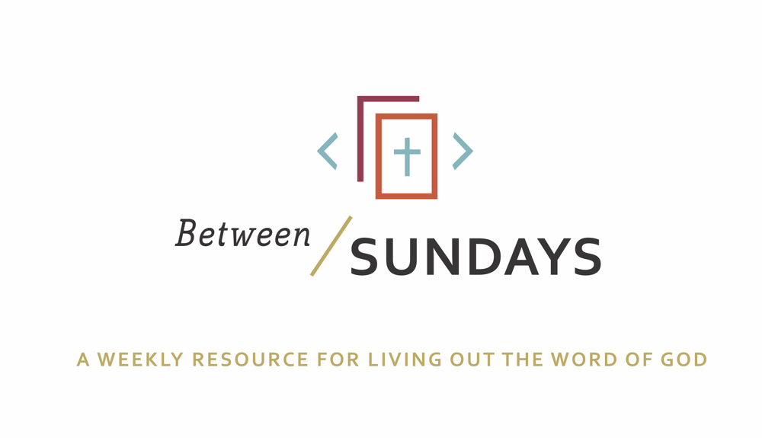
What: a weekly resource that helps the community of CCE take the sermon into their lives throughout the week with a variety of reflections, group discussions, and individual practices.
Why: Sermons aren't just for Sunday morning. “We submit ourselves to the way of faith and practice revealed in the Word of God. The sermon is explanation and exhortation, making this Word clear and applying it to our lives.” (definition on bulletin)
Individual and communal rhythms that help us take the liturgy into daily life allow us to open ourselves to what God is teaching us through his Word and his people.

Feel free to go through all the days, or select one or two exercises that help you apply the sermon to your life this week.

March 8, 2020, 2020
Sermon Title: Overcoming Anxiety
Scott Armstrong
Passage: Psalm 27
NT Reading: Philippians 4:4-7

Key Idea: Summary: Coronavirus. Market Volatility. Political instability. Just a few of the words inciting fear, worry and anxiety in our hearts. When we are confronted by forces beyond our control, our tendency is to panic and “fix” things and when we realize we can't fix something, we are consumed by fear and anxiety. However, we were not meant to live this way and what Psalm 27 teaches is that we can have confidence not after troubles have passed by during our troubles. David was a king who knew about trouble but he persisted in confident worship of God despite his circumstances and we can too. And we know we can because the Father sent His Son who received the terror of sin, hell and death upon Himself at the Cross so that we might know that today’s terrors will not consume or destroy our identities.

Monday: Lectio Divina
Take some time to practice an ancient way of reading Scripture. For more on lectio divina, see the additional resources at the end.

-(Lectio) Reading. Slowly read the sermon text (Psalm 27) and get a sense of what it is saying. Read it a second time and listen for any words that strike you.
- (Meditatio) Reflecting. Read the passage again slowly. As you pause on the words or phrases that stick out to you, take some time to consider what the word, passage, or phrase means (in the context of Scripture) and how God might be using it to speak to anything in particular in your life.
- (Oratio) Responding. Read the passage again, slowly. Consider now how God has spoken to *you* in this passage and respond back to him.
- (Contemplio) Remaining. Now, take time to simply remain in the presence of God.

Tuesday: Discussion Guide
Each week we’ll provide some questions to consider that will help you take the Scripture and the sermon into a deeper place. We hope this fosters meaningful conversations with those in your community group, your spouse or a friend. Authentic change happens in community.

- Read Philippians 4:4-7. What aspect of your life is being touched, challenged or spoken to through this Scripture? What would you like to say to Jesus about that? (The text invites us to “let our requests be made known to God”) Invite the members of your family or community group to share.

- Scott said threats force us to choose a pathway at the “fork” in the road—either confront the trouble head on or seek to medicate and numb. What choice do you often make at the fork in the road and why?

- Scott said that pain and trouble is a gift that compels us to live in reality. Do you see pain in this way? What would your life look like if it was pain free?

- Scott said that David had freedom from fear because he made his “one thing” (v. 4) the voice and face of God (intimacy)—that it grounded him in true reality. Do you feel like you know this sort of freedom from fear?

- How does waiting on the Lord in prayer (v. 14) ground you in God? Given the current global pandemic, how could “walking in the way of the Lord” (v11) shift your perspective? How can your family and those in your neighborhood community group help you choose confidence in the character and story of God, rather than your own way or the worlds way?

- The next few weeks will require us to stay in our homes more than we typically would as we wait and pray for the global health crisis to subside. Think about David’s prayer in Psalm 27– “one thing I ask of the Lord, that I will seek after- to dwell in the house of the Lord all the days of my life.” What was the psalmist speaking of? David was a shepherd, and spent a significant amount of time alone, yet God used the solitude to shape David’s heart in beautiful ways. Pray now for times solitude and silence with God, where he will shape your heart to be more like his.

Wednesday: Review of Confession

Father, we confess today that we often live as if our actual confession is that this world is all that exists and we are left to our own devices to fix things. We have turned to fear, worry and anxiety in an effort to control the uncontrollable, rather than turn to the One who is in control. Forgive us for making our “one thing” other things besides You. Revive our memories that in Christ, we have the power we need today to deal with chaos and tribulation. Guard our hearts, Holy Spirit, in Christ Jesus, Our Lord, granting us peace. Amen.
Spend some time talking with God. Perhaps this corporate confession stirred some deeper places in your soul that need to receive His grace.

As you received communion this past Sunday, what burden did God free your heart from?
Where do you sense God drawing you further to himself, his community, the world?

Thursday: Hymn Devotional
Psalm 27 tells us that God is our stronghold even through the darkest times. Let us dwell on the kindness, power, and beauty of the Lord God Almighty with O For a Thousand Tongues To Sing.

O For a Thousand Tongues To Sing

Oh for a thousand tongues to sing
My great Redeemer’s praise
The glories of my God and King
The triumphs of His grace

He breaks the power of canceled sin
He sets the prisoners free
His blood can make the foulest clean
His blood availed for me

Oh for a thousand tongues to sing
Oh for a thousand years to praise
The glories of my God and King
The triumphs of His grace
My great Redeemer’s name

My gracious Master and my God
Assist me to proclaim
To spread through all the earth abroad
The honors of Thy name
Jesus the name that charms our fears
That bids our sorrow cease
‘Tis music in the sinner’s ears
‘Tis life and health and peace

Friday: Sabbath/Soul Rest
Take a few minutes— ideally at the beginning of your day, or whenever works best for you— and simply do nothing. Just be. Stand in love before God. Sit there long enough for the peace of his spirit to well up inside your body.

Let Your God Love You
By: Edwina Gateley

Be silent.
Be still.
Alone.
Empty
Before your God.
Say nothing.
Ask nothing.
Be silent.
Be still.
Let your God look upon you.
That is all.
God knows.
God understands.
God loves you
With an enormous love,
And only wants
To look upon you
With that love.
Quiet.
Still.
Be.

Let your God—
Love you.

This guide can be used with all members of your family! But the younger ones in particular, might enjoy having their Sunday school lesson taught by Mom and Dad, or older siblings? Here’s a link to the curriculum we use at City Church:

Lifeway has created a LifeWay Kids at Home Digital Pass experience. This Digital Pass experience is a temporary resource to supplement Sunday School from home. There will be a video session with a downloadable Activity Page and One Conversation Sheet available weekly. To get the Digital Pass and access LifeWay Kids at Home, please have each of your families follow the steps below.
Step 1: Go to my.lifeway.com/redeem
Step 2: Register if you are a new user or log in if you already have an account
Step 3: Enter this redemption code: VZMD4SSQ38
Step 4: Click "Access" (if prompted to sign in again, sign in) and then click "My Dashboard," and go to LifeWay Kids at Home
Step 5: Download your Activity Page and One Conversation Sheet to use as you watch the video session

Also, the Jesus Storybook Bible has a chapter on “How to Pray” from Matthew 6 that might be a good resource this week. (Page 222)

