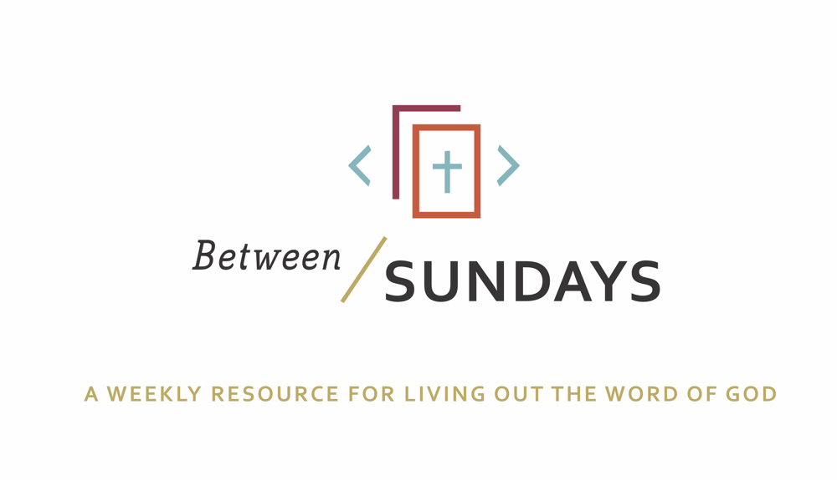
What: a weekly resource that helps the community of CCE take the sermon into their lives throughout the week with a variety of reflections, group discussions, and individual practices.
Why: Sermons aren't just for Sunday morning. “We submit ourselves to the way of faith and practice revealed in the Word of God. The sermon is explanation and exhortation, making this Word clear and applying it to our lives.” (definition on bulletin)
Individual and communal rhythms that help us take the liturgy into daily life allow us to open ourselves to what God is teaching us through his Word and his people.

Feel free to go through all the days or select one or two exercises that help you apply the sermon to your life this week.

January 19, 2020

Sermon Series: 2020 Vision
Title: A Church of Generosity
Scott Armstrong
Sermon Text: Acts 2:42-47
OT Reading: Deuteronomy 6: 1-7

He works on us in all sorts of ways. But above all, He works on us through each other. Men are mirrors, or “carriers” of Christ to other men. Usually it is those who know Him that bring Him to others. That is why the Church, the whole body of Christians showing Him to one another, is so important. It is so easy to think that the Church has a lot of different objects—education, building, missions, holding services…The Church exists for no other purpose but to draw men into Christ, to make them little Christs. If they are not doing that, all the cathedrals, clergy, missions, sermons, even the Bible itself, are simply a waste of time. God became man for no other purpose. It is even doubtful, you know, whether the whole universe was created for any other reason. C.S. Lewis, Mere Christianity

Monday: Lectio Divina
Take some time to practice an ancient way of reading Scripture. For more on lectio divina click here
- (Lectio) Reading. Slowly read the sermon text (Acts 2:42-47) and get a sense of what it is saying. Read it a second time and listen for any words that strike you.
- -(Meditatio) Reflecting. Read the passage again slowly. As you pause on the words or phrases that stick out to you, take some time to consider what the word, passage, or phrase means (in the context of Scripture) and how God might be using it to speak to anything in particular in your life.
- (Oratio) Responding. Read the passage again, slowly. Consider now how God has spoken to *you* in this passage and offer your responses back to Him.
- (Contemplio) Remaining. Now, take time to simply remain in the presence of God.

Tuesday: Discussion Guide
Each week we’ll provide some questions to consider that will help you take the Scripture and the sermon into a deeper place. We hope this fosters meaningful conversations with those in your community group, your spouse or a friend. Authentic change happens in community.

- Scott opened by saying the church is be devoted to the vertical life (apostles teaching ,etc, last week’s sermon) as well as horizontal life (mercy, generosity, community). Which “life” (vertical or horizontal) comes more naturally to you and why?

- Scott said everyone has a need that the church can meet—have you ever considered that before? What might one need be in your life that the church (fellow believers at City Church) can help meet?

- Consider 2 Corinthians 8:9: For you know the grace of our Lord Jesus Christ, that though he was rich, yet for your sake he became poor, so that you by his poverty might become rich. How does the Good News that Jesus Christ was extravagantly generous towards you help shape your attitude towards giving (time, talent, treasure) at City Church or elsewhere?

- Up until now, would you identify yourself more as a consumer or contributor to the Christian/church community? Scott talked about a vision of “unlocking potential” to be contributors, leading to satisfaction and greater humanity—what would you like to see unlocked inside you in 2020?

Wednesday: Review of Confession

We confess corporately to acknowledge that we all alike fall short of the glory of God, but we also all alike can rest with assurance on His amazing grace.

God, we confess to you as a church family that we have often turned away from the abundant life your Gospel teaches for us. We have acted more like individuals in charge of our own destiny than members of a community designed to express love one to another. We have hidden in shame, unwilling to expose our needs to others. And we have embraced the life of a consumer without a commitment to contributing to your kingdom in ways we were made to. Forgive us, Father. Jesus, make us little Christs—generous to a fault, willing to empty ourselves of resources the way you emptied yourself on the Cross for us. Thank you for the way you make us more truly human and abundant, satisfying our hearts. Amen.

We receive communion each week at City Church because we are forgetful people; between Sundays we allow other voices to overshadow our true plumb-line. The bread and the wine serve as symbols of the reality of Jesus— a means of grace that point to our true plumb line, the voice of the Father.

Thursday: Hymn Devotional

Listen to this traditional hymn and sing/pray these words to Jesus:

Let us Talents and Tounges Employ

Let us talents and tongues employ,
reaching out with a shout of joy:
bread is broken; the wine is poured;
Christ is spoken and seen and heard.

Jesus lives again; earth can breathe again;
pass the Word around: loaves abound!
Jesus lives again; earth can breathe again;
pass the Word around: loaves abound!

Christ is able to make us one;
at the table he sets the tone,
teaching people to live to bless,
love in word and in deed express.

Jesus calls us in, sends us out
bearing fruit in a world of doubt,
gives us love to tell, bread to share:
God [Immanuel] everywhere!

Friday: Sabbath/Soul Rest

Take a few minutes— ideally at the beginning of your day, or whenever works best for you— and simply do nothing. Just be. Stand in silent love before God. Sit there long enough for the peace of his spirit to well up inside your body. Thank him for it. Ask God, “What do you have for me today?”

“O Lord, your unfailing love fills the earth; teach me your decrees” Psalm 119:64

Additional Resources:

This week we celebrate Martin Luther King Jr. Day. Scott mentioned a quote from Martin Luther King Jr.’s famous speech “Birth of a New Nation.” Feel free to review the entire speech here.

