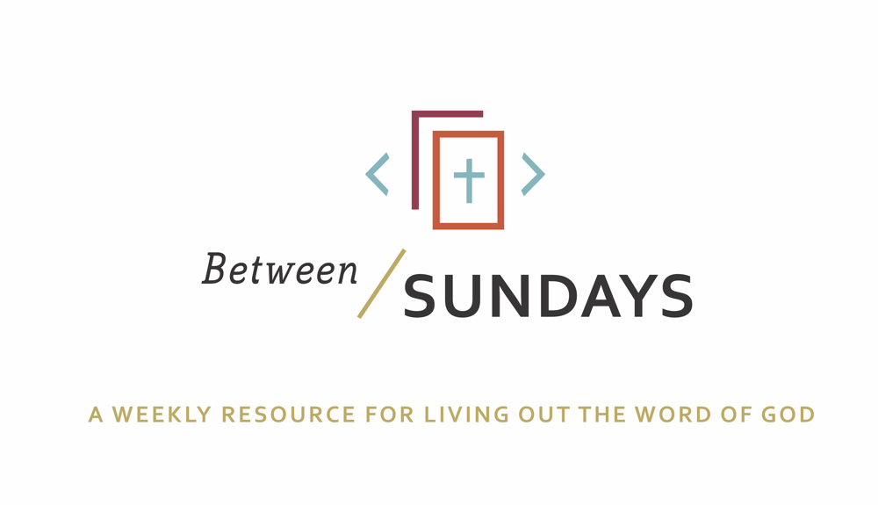
What: a weekly resource that helps the community of CCE take the sermon into their lives throughout the week with a variety of reflections, group discussions, and individual practices.
Why: Sermons aren't just for Sunday morning. “We submit ourselves to the way of faith and practice revealed in the Word of God. The sermon is explanation and exhortation, making this Word clear and applying it to our lives.” (definition on bulletin)
Individual and communal rhythms that help us take the liturgy into daily life allow us to open ourselves to what God is teaching us through his Word and his people.

Feel free to go through all the days or select one or two exercises that help you apply the sermon to your life this week.

October 27, 2019

Sermon Title: Work Gone Bad
Scott Armstrong
Passage: Genesis 11:1-9

Key Idea: Our identity is formed in Christ, not in what we do.

Summary: The citizens of Babel insisted on doing things their way, instead of ordering their life after God’s Ways. They lost touch with His voice, and listened to their own, which lead to a path of destruction. The sermon teaches us that losing touch of God’s voice, and basing our identity in our work, or other idols, is a fragile way to live, which only leads to our destruction. Anytime we allow pride, fear, work, or other motivators to be the foundations of our identity, we are making a name for ourselves. This way of living will never satisfy. Scott said, “Without the power of Christ, we are merely worker bees in the colony of humanity.” But, because of Jesus, we are re-made, redeemed, and re-named.

Monday: Lectio Divina
Take some time to practice an ancient way of reading Scripture. For more on lectio divina click here

-(Lectio) Reading. Slowly read the sermon text (Genesis 11:1-9) and get a sense of what it is saying. Read it a second time and listen for any words that strike you.
- (Meditatio) Reflecting. Read the passage again slowly. As you pause on the words or phrases that stick out to you, take some time to consider what the word, passage, or phrase means (in the context of Scripture) and how God might be using it to speak to anything in particular in your life.
- (Oratio) Responding. Read the passage again, slowly. Consider now how God has spoken to *you* in this passage and offer your responses back to Him.
- (Contemplio) Remaining. Now, take time to simply remain in the presence of God.

Tuesday: Discussion Guide
Each week we’ll provide some questions to consider that will help you take the Scripture and the sermon into a deeper place. We hope this fosters meaningful conversations with those in your community group, your spouse or a friend. Authentic change happens in community.

- The story of the tower of Babel is full of so many lessons for us today. Scripture tells us that God had commanded humankind to be fruitful and multiply, and to fill the earth. In this story, eleven chapters into the Bible, mankind had yet again lost touch with the voice of God. They were only listening to their voice (their desires, fears, motivations, dreams) Think of a recent example when you’ve lost touch of God’s voice. What makes your voice (your desires, fears, motivations, dreams) so compelling, and louder, than the voice of God?
- The heart of God was grieved because of the pattern of disobedience and hardening of hearts in Babel. In his mercy, God came to earth to stop the building of the tower. He confused the languages of the people, and their efforts were halted. Can you think of examples in your life when God visited you, and in his mercy prevented you from continuing a destructive path? Perhaps he used other people, his Word, a difficult season or other events to stall your efforts. Take a few moments to reflect on that time in your life and share about how you experienced God, and how he helped you reconstruct your life.
- Reflect on the C.S. Lewis quote on the cover of the bulletin, “…Pride is essentially competitive. It gets no pleasure out of having something, only of having more of it than the next man. We say people are proud of being rich, or clever, or good-looking but they are not. They are proud of being richer, or cleverer, or better-looking than others.” Take a moment to consider how the sin of pride has reared its head in your life. Confess to God, and others if necessary, places that your pride has come between you and God, or your relationships.

- A few weeks ago, one of the discussion questions invited us to make a list and contrast the voice of God with the voice of Satan. Have a look at that list and add anything to the columns that this sermon might have illustrated. How has that exercise helped you be more in tune with the voice of God? Is recognizing the voice of the enemy getting easier? Why/Why not? Share with your group a way they can help affirm the voice of the Father in your life, and ways they can hold you accountable to resisting the tempter’s voice.

Wednesday: Review of Confession

Father, in our work, we often are building the city of man, and not the city of God. We do it because we are anxious, fearful and insecure, distrusting that your name for us is enough. We have constructed names for ourselves—reputations acquired through workaholism, the pursuit of self-glory, the need to achieve and so much more. But we are still anxious, fearful, and tired. We are scattered people, living apart from your vision for this world. Forgive us Father, give us a new name through Jesus Christ and restore to us your peace. Amen.

Spend some time talking with God. Perhaps this corporate confession stirred some deeper places in your soul that need to receive His grace.

As you received communion this past Sunday, what burden did God free your heart from?
Where do you sense God drawing you further to himself, his community, the world?

Thursday: Hymn Devotional

On Sunday we sang a few lines of the song, “My Hope is Built on Nothing Less” (On Christ the Solid Rock I Stand) Listen to the song and then read the parable of the two builders (Matt 7:24-27)

Jesus ends the Sermon on the Mount with this parable. It’s not enough to merely listen to his words, we must put them into practice and build our life around His ways. Otherwise we are like the foolish man, who lacks good moral judgement and doesn’t listen to the voice of God.
When we try to obey in our own strength, it is a burden. When we do it with God’s strength and help, it is a delight.

This week consider what you are ‘trying to build with your own hands’.
Where are you tempted to make a name for yourself?
Ask Jesus to help you ground your ordinary moments in his solid power, instead of the “sinking sand” of your own pride, desires, idols, or motivations.

Friday: Sabbath/Soul Rest (The Discipline of Doing Nothing)

Each week we’ll take time to practice a holy rest. Set aside some time this week to practice the discipline of doing nothing. Thank God for the gift of rest. Do not make lists or write in a journal or try to “do” prayer. Sometimes being still is one of the most difficult prayers to pray. Challenge yourself to receive the GIFT of a distraction-free rest, even for just a few minutes.

“BE STILL and know that I am God.” Psalm 46:10

Additional Resources:
Check out Every Moment Holy for liturgies for daily life (changing diapers, morning coffee, etc)
Made to Flourish seeks to close the gap in our churches between Sunday and Monday. www.madetoflourish.org
Podcast: The Next Right Thing Episode 88 “Come Away for a While”
Book: Liturgy of the Ordinary by Tish Harrison Warren

Scott also mentioned these books in his sermon:
Triumph of the City by Edward Glaeser
Parenting with Love and Logic by Cline and Fay

