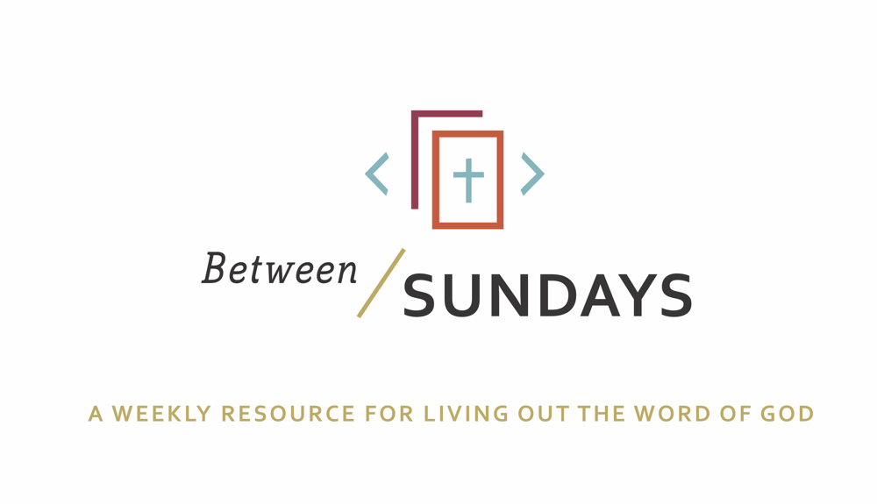
What: a weekly resource that helps the community of CCE take the sermon into their lives throughout the week with a variety of reflections, group discussions, and individual practices.
Why: Sermons aren't just for Sunday morning. “We submit ourselves to the way of faith and practice revealed in the Word of God. The sermon is explanation and exhortation, making this Word clear and applying it to our lives.” (definition on bulletin)
Individual and communal rhythms that help us take the liturgy into daily life allow us to open ourselves to what God is teaching us through his Word and his people.

Feel free to go through all the days or select one or two exercises that help you apply the sermon to your life this week.

January 12, 2020

Sermon Series: 2020 Vision
Title: A Church of Devotion
Scott Armstrong
Sermon Text: Acts 2:42-47
OT Reading: Ezekiel 36:22-27

Cover Quote: “ The Church: God gave us the miracle of congregation with the same sign he gave us the miracle of Jesus, by the descent of the dove. The Holy Spirit descended into the womb of Mary in the Galilean village of Nazareth. Thirty or so years later the same Holy Spirit descended into the collective womb of men and women, which included Mary, who had been followers if Jesus. The first conception gave us Jesus, the second conception gave us church.” Eugene Peterson

Monday: Lectio Divina
Take some time to practice an ancient way of reading Scripture. For more on lectio divina click here
-(Lectio) Reading. Slowly read the sermon text (Acts 2:42-47) and get a sense of what it is saying. Read it a second time and listen for any words that strike you.
- (Meditatio) Reflecting. Read the passage again slowly. As you pause on the words or phrases that stick out to you, take some time to consider what the word, passage, or phrase means (in the context of Scripture) and how God might be using it to speak to anything in particular in your life.
- (Oratio) Responding. Read the passage again, slowly. Consider now how God has spoken to *you* in this passage and offer your responses back to Him.
- (Contemplio) Remaining. Now, take time to simply remain in the presence of God.

Tuesday: Discussion Guide
Each week we’ll provide some questions to consider that will help you take the Scripture and the sermon into a deeper place. We hope this fosters meaningful conversations with those in your community group, your spouse or a friend. Authentic change happens in community.

1.Does being part of the local church excite you or leave you bored? Why or why not? What was attractive about the Body of Christ, the Church, that drew you to it in the first place?

2. What hopes and dreams for the church (both City Church and the global church family) do you have?

3. Scott spoke at length about “devotion” and how easily our devotions become disordered loves. Where have you been tripped up by devotions apart from God?

4. Scott gave the example of a plumb-line that orients objects or buildings to the true center. God gave us the church to keep our plumb-line in position with his heart, our true center. Share some ways that the Holy Spirit, the Church, or the Word has served as a plumb line in your life recently.

5. Read Ezekiel 36:26-27 and reflect on how the spirit creates in us a new heart— one of flesh, not stone. Mature spirituality is measured by an increasing capacity to love God and others. How does our spiritual formation bring glory to God, and draw others to a relationship with him?

6. What commitments “to the right things” (eg, apostles teaching, prayer, worship) can you make moving forward? Perhaps consider making a “Resolution” around a practice mentioned on Sunday, trusting that the rhythm will be used by God to build you up in Christ.

Wednesday: Review of Confession

We confess corporately to acknowledge that we all alike fall short of the glory of God, but we also all alike can rest with assurance on His amazing grace.

God, our hearts are pricked by you, Jesus, the Living Truth. You have revealed how scattered our devotions are and how we have been devoted to the wrong things. We have forgotten our true plumbline, Jesus Christ, revealed to us in the Scriptures, and have been adrift and lost in a chaotic world. Forgive us, Jesus Christ. Draw us back to the white, hot center of your love and call us to bend the knee to you as Lord and our one true, loving authority. Through the renewing work of the Spirit, build a church for the nations that you would be center of our lives and the lives of others. Amen.

We receive communion each week at City Church because we are forgetful people; between Sundays we allow other voices to overshadow our true plumb-line. The bread and the wine serve as symbols of the reality of Jesus— a means of grace that point to our true plumb line, the voice of the Father.

Thursday: Hymn Devotional

Listen to this song by Rend Collective and sing/pray these words to Jesus

My Lighthouse

In my wrestling and in my doubts
In my failures You won't walk out
Your great love will lead me through
You are the peace in my troubled sea
You are the peace in my troubled sea
In the silence, You won't let go
In the questions, Your truth will hold
Your great love will lead me through
You are the peace in my troubled sea
You are the peace in my troubled sea
My lighthouse, my lighthouse
Shining in the darkness. I will follow You
My lighthouse, my lighthouse
I will trust the promise
You will carry me safe to shore
Safe to shore
Safe to shore
I won't fear what tomorrow brings
With each morning I'll rise and sing
My God's love will lead me through
You are the peace in my troubled sea
You are the peace…

Friday: Sabbath/Soul Rest

Take a few minutes— ideally at the beginning of your day, or whenever works best for you— and simply do nothing. Just be. Stand in silent love before God. Sit there long enough for the peace of his spirit to well up inside your body. Thank him for it. Ask God, “What do you have for me today?”

“BE STILL and know that I am God.” Psalm 46:10

Additional Resources:

The Frederick Douglass biography that Scott mentioned is found here
The Spirit of the Disciplines by Dallas Willard

