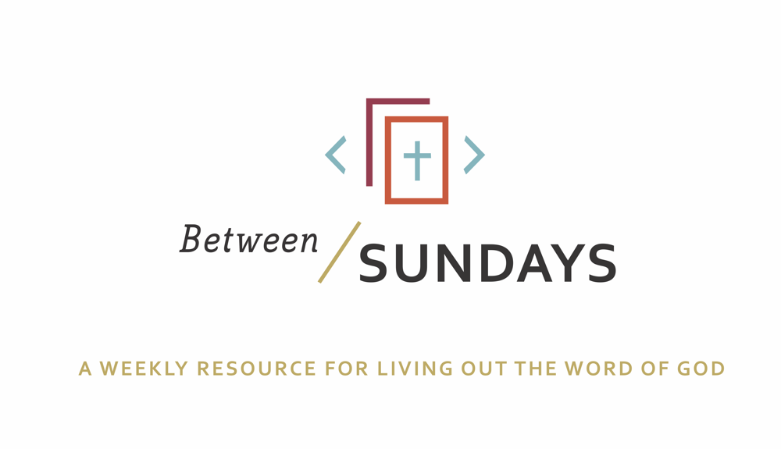
What: a weekly resource that helps the community of CCE take the sermon into their lives throughout the week with a variety of reflections, group discussions, and individual practices.
Why: Sermons aren't just for Sunday morning. “We submit ourselves to the way of faith and practice revealed in the Word of God. The sermon is explanation and exhortation, making this Word clear and applying it to our lives.” (definition on bulletin)
Individual and communal rhythms that help us take the liturgy into daily life allow us to open ourselves to what God is teaching us through his Word and his people.

Feel free to go through all the days or select one or two exercises that help you apply the sermon to your life this week.

November 24,, 2019
Scott Armstrong
Title: The Future of Rest is Now

Sermon Text: Isaiah 32: 1-2, 15-20

Cover Quote: “Unless one learns how to relish the taste of Sabbath while still in this world, unless one is initiated in the appreciation of eternal life, one will be unable to enjoy the taste of eternity in the world to come…. The essence of the world to come is Sabbath eternal, and the seventh day in time is an example of eternity.” Rabbi Heschel

Monday: Lectio Divina
Take some time to practice an ancient way of reading Scripture. For more on lectio divina click here

-(Lectio) Reading. Slowly read the sermon text (Isaiah 32:1-2, 15-20) and get a sense of what it is saying. Read it a second time and listen for any words that strike you.
- (Meditatio) Reflecting. Read the passage again slowly. As you pause on the words or phrases that stick out to you, take some time to consider what the word, passage, or phrase means (in the context of Scripture) and how God might be using it to speak to anything in particular in your life.
- (Oratio) Responding. Read the passage again, slowly. Consider now how God has spoken to *you* in this passage and offer your responses back to Him.
- (Contemplio) Remaining. Now, take time to simply remain in the presence of God.

Tuesday: Discussion Guide
Each week we’ll provide some questions to consider that will help you take the Scripture and the sermon into a deeper place. We hope this fosters meaningful conversations with those in your community group, your spouse or a friend. Authentic change happens in community.

1. Where do you lack an equilibrium of rest in your life right now and why?

2. Scott said the provision of rest was the giving of the Holy Spirit through Jesus Christ. How have you experienced encouragement as a Christian through the work of the Spirit in your life?
Describe that moment or experience and how it impacted you.

3. What practices or disciplines best allow you to sense the Holy Spirit? (example: reading the Bible, praying, silence, solitude)

4. In Isaiah, it says.... “And the effect of righteousness will be peace, and the result of righteousness, quietness and trust forever.” (Is 32:17) What is keeping you from experiencing this peace and quietness that Isaiah refers to? What do you imagine that would look like in your present circumstances?

5. True peace won’t be found in practicing mindfulness techniques or a adopting a different political viewpoint, but is a gift from the Holy Spirit. (Is 32:15) Share about a time you pursued external circumstances to give you peace. How did you discover that path wasn’t giving you the peace/rest/joy you hoped it would?

6. Scott concluded by saying the results of the giving of rest by God are peace (shalom) and a new longing to practice the work of renewal in our world through the church. Are there areas of life where the Lord has either called you or you sense He may be calling you to practice the “resurrection life” through your work, paid and unpaid?
Wednesday: Review of Confession

God, we are often stuck in our present moment, full of frustrations anxiety and stress by things happening outside of us and things happening within us. We are not at rest because our hearts are restless. We have forgotten that Jesus has secured our forever peace and that peace can give us rest today. Forgive us for our striving, our anxious worry and our exhaustive ambitions. Replace them with the resurrection hope of Jesus and the hope that one day we will have perfect rest. Cause us to work today from a place of rest because you have heard our confession and the righteousness of Jesus has covered our sin. Amen.

As you read the confession again, consider what places, relationships, or situations you might feel “stuck” currently.

Saint Augustine of Hippo, in Confessions, his autobiographical letter to God, which would become one of the most famous books in literature, pens the words: “You have made us for yourself, and our hearts are restless, until they can find rest in you.”
Take some time to reflect on that quote, and invite God to give you His rest in this moment.

Thursday: Hymn Devotional
Sunday we sang In Feast or Fallow by Sandra McCracken, listen again here

On this Thanksgiving day, may your heart be filled with gratitude that no matter what external circumstances you face, the God of true peace, gives you a secure foundation on which to base your hope.

Write a few lines of thanks to God for how his presence has sustained you this past year.

Friday: Sabbath/Soul Rest (The Discipline of Doing Nothing)

Each week we’ll take time to practice a holy rest. Set aside some time this week to practice the discipline of doing nothing. Thank God for the gift of rest. Do not make lists or write in a journal or try to “do” prayer. Sometimes being still is one of the most difficult prayers to pray. Challenge yourself to receive the GIFT of a distraction-free rest, even for just a few minutes.

“BE STILL and know that I am God.” Psalm 46:10

Additional Resources:
As we enter the next season of the church calendar this week, give some thought to how you would like to observe Advent. Whether you want to make an advent wreath with your children, find a devotional to help you experience this month, or simply acknowledge it each Sunday as you honor Sabbath. Receive the invitation to rest and not add a layer of obligation to this already busy season.
Some music for your Advent: Waiting Songs https://www.amazon.com/dp/B016IWEIO2/ref=cm_sw_r_cp_api_i_rmU2DbVG2FNV6

Podcast: Rhythms for Life Rebecca Lyons “Made for Meaning”
https://podcasts.apple.com/us/podcast/made-for-meaning-rebekah-lyons/id1477541494?i=1000451886055

Book: Surprised by God by N.T. Wright

