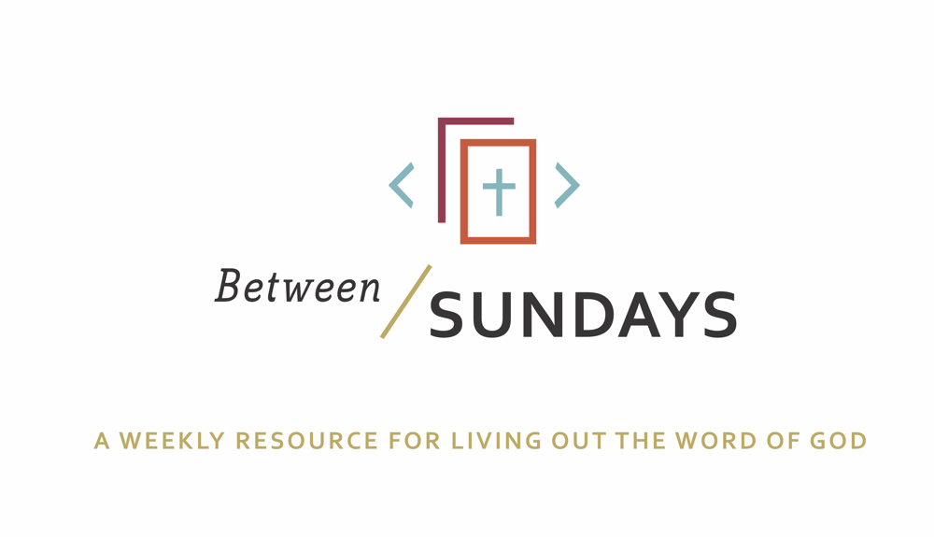
What: a weekly resource that helps the community of CCE take the sermon into their lives throughout the week with a variety of reflections, group discussions, and individual practices.
Why: Sermons aren't just for Sunday morning. “We submit ourselves to the way of faith and practice revealed in the Word of God. The sermon is explanation and exhortation, making this Word clear and applying it to our lives.” (definition on bulletin)
Individual and communal rhythms that help us take the liturgy into daily life allow us to open ourselves to what God is teaching us through his Word and his people.

Feel free to go through all the days, or select one or two exercises that help you apply the sermon to your life this week.

March 22, 2020
Sermon Title: Searching for Comfort
Scott Armstrong
Passage: Psalm 23
NT Reading: John 10:7-15

Cover Quote: C.S. Lewis, “On Living in An Atomic Age”: This is the first point to be made: and the first action to be taken is to pull ourselves together. If we are all going to be destroyed by an atomic bomb, let that bomb when it comes find us doing sensible and human things—praying, working, teaching, reading, listening to music, bathing the children, playing tennis, chatting to our friends over a pint and a game of darts—not huddled together like frightened sheep and thinking about bombs. They may break our bodies (a microbe can do that) but they need not dominate our minds.
Summary: Once again, the Psalms address current reality, demonstrating how timely God’s word is. Pestilence, plagues. Fears, anxieties. There is nothing new under the sun but because of medical advances and because we live largely in a world of comfort, when that life is shattered, it can leave us internally shattered, where we live out of our projections of what life should be like rather than the life that has actually occurred. Out in this “wilderness,” we can forget past rescue from God and be tempted to only see fear or God’s absence. The Psalmist in Psalm 23 is well aware that their troubles are great—he describes it as a valley of death’s shadow—but he begins and ends this short psalm in the same way—we have a good shepherd who guides us through dark valleys. Part of what it means to be a Christian is to live realistically (we prepare along with all others for what we all face) but we always life today in light of tomorrow. We are people of hope. The Psalmist understood that. What is truly remarkable is with the coming of Jesus, we meet one who also was tempted in the wilderness but did not sin. He passed the test we could not so that we can be relieved from crippling fear. May we be the church hopeful in the days ahead.

Monday: Lectio Divina
Take some time to practice an ancient way of reading Scripture. For more on lectio divina, see the additional resources at the end.

-(Lectio) Reading. Slowly read the sermon text (Psalm 23) and get a sense of what it is saying. Read it a second time and listen for any words that strike you.
- (Meditatio) Reflecting. Read the passage again slowly. As you pause on the words or phrases that stick out to you, take some time to consider what the word, passage, or phrase means (in the context of Scripture) and how God might be using it to speak to anything in particular in your life.
- (Oratio) Responding. Read the passage again, slowly. Consider now how God has spoken to *you* in this passage and respond back to him.
- (Contemplio) Remaining. Now, take time to simply remain in the presence of God.

Tuesday: Discussion Guide
Each week we’ll provide some questions to consider that will help you take the Scripture and the sermon to a deeper place. We hope this fosters meaningful conversations with those in your community group, your spouse or a friend. Authentic change happens in community.

- How has fear invaded your life through the current [COVID19 pandemic] crisis?

- When our false sense of protection is stripped away, it reveals what our faith is based on. As the sermon reminded us— this is not an interruption to life, this is life! We are not promised a life without suffering. Yet, we have such a tight grip on our temporal expectations for how things “should” be. What false sense of protections have you lost in the past week? (Ex: control over your schedule, health, job, etc) What has it taught you about your faith?

- The Bible is full of stories of God’s people in seasons of “wilderness”— a spiritual place of testing when God’s people question his goodness. It’s safe to say the Church is being tested in this current global crisis. Scripture refers to this as a “refiners fire” (Zech 13:9, 1 Pet 1:7, Job 23:10, Prov 17:3, 1 Pet 5:10, Mal 3:2-3, James 1:12, Rom 5:3-4, Isaiah 43:2) Look up a few of the passages above. How might God be refining His Church in this season?

- Scott said that the troubles of this passage (v. 4) are surrounded by the Shepherd’s comforting presence. How can knowing God is there and cares (as demonstrated through the gift of His Son) encourage you today?

- Scott said that he experienced God’s guiding presence especially through the church family providing for them in their hour of need. This is referred to as a “means of grace”-a way in which God works through his people to draw them closer to himself. Think of a time that God used others to minister to you during a difficult time, and your faith was strengthened as a result.

- Take some time to pray with and for each other and check with your Neighborhood Community on how you can serve your neighbors and one another this week.

Wednesday: Review of Confession

Father, we are living in fearful times. We acknowledge that being a Christian neither protects us from pestilence nor guarantees freedom from fear. Father, if we have responded to the current crisis in any way that harms others or ourselves, would you expose that in us? Father, if we indeed have lived like that, forgive us and spread your kindness and love over us as we grapple with a “new normal.” Remind us that Jesus is our Good Shepherd who ushers us through the valley of the shadow of death (Psalm 23:4) and will lead us into goodness and mercy the rest of our days (Psalm 23:6). Amen.

Thursday: Hymn Devotional
Leaning on the Everlasting Arms
By Elisha Albright Hoffman (1887)

What a fellowship, what a joy divine,
Leaning on the everlasting arms;
What a blessedness, what a peace is mine,
Leaning on the everlasting arms.

Refrain:
Leaning, leaning,
Safe and secure from all alarms;
Leaning, leaning,
Leaning on the everlasting arms.
Oh, how sweet to walk in this pilgrim way,
Leaning on the everlasting arms;
Oh, how bright the path grows from day to day,
Leaning on the everlasting arms.
What have I to dread, what have I to fear,
Leaning on the everlasting arms?
I have blessed peace with my Lord so near,
Leaning on the everlasting arms.

**Take courage Church! The Saints before us have experienced difficult seasons of uncertainty, pain, and testing of their faith. Sing this hymn with confidence, and lean into his safe arms today, so that we can be His arms to the world.**

Friday: Sabbath/Soul Rest

As you spend some time in God’s presence today, consider this from the Life With God Bible note on Psalm 23:6:
“Goodness and mercy shall follow me all the days of my life…”
Mercy here, is God’s hesed, the love that never quits. It is a love that doesn’t just follow, but always pursues us. To perceive God’s love as pursuing rather than begrudged deepens our ability to trust.

